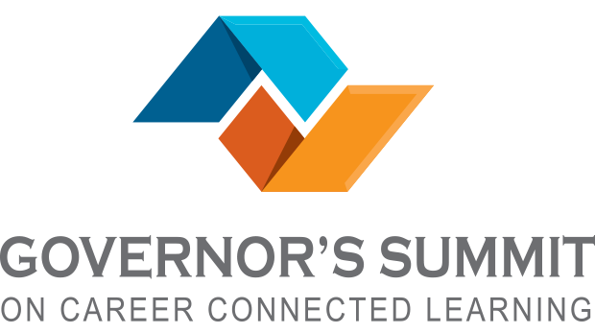

Please join us for Governor Inslee’s Summit on Career Connected Learning! You’ll be part of a group of industry, policy, and education leaders working together to share best practices to increase and strengthen career-related opportunities for Washington’s youth in high demand jobs.

Wednesday, May 31, 10am - 1:30pm
South Thurston Fire & EMS Station, 187 Hodgden Rd S., Tenino WA 98589.
Register here: Tenino
Visit www.washingtonstem.org/govsummit for more details

The Governor's Summit will be simultaneously hosted onsite in Redmond, on the Microsoft campus, and at 27 regional sites around the state.

The regional sites will connect via webinar technology with the central Summit during the general session to learn about statewide career connected learning activities and plans. We’ll then convene locally to discuss the information shared by the panelists and address local opportunities, challenges, and solutions to provide youth with career connected learning experiences. Information gathered at these sites will be collected and shared with the Governor’s office and others working on next steps regarding career connected learning in our state.

Discussions will focus on helping more Washington youth gain access to a wide range of career-connected learning opportunities, including:
- Internships
- Apprenticeships
- Job shadows
- Mentorships
- Job fairs
- Classroom visits from area employers

Washington businesses consistently report difficulty in finding hires with work-ready skills to fill key positions. There will be 740,000 job openings over the next five years in Washington alone. Career-connected learning has been proven to help young people complete their education goals and find meaningful pathways to employment.

Gov. Inslee will deliver live remarks at a central location at the Microsoft Campus in Redmond before an audience of 400 people, Inslee’s presentation will also be streamed live to regional sites, bringing the total audience to about 1,000 individuals.

Gov. Inslee’s remarks will be followed by discussions where community leaders will be able to ask questions, learn more about how to help young people in their own area gain work experience, and create a pipeline of skilled workers to meet the needs of business.

Please feel free to forward this invitation to members of your organization or community you think would be interested in participating.

Be sure to register ASAP. We are anticipating that the Tenino location is going to fill up quickly!
For more information contact the Thurston Economic Development Council’s Community & Rural Development Manager, Aslan Meade: 360-789-8843, ameade@thurstonedc.com.

